|  |  |
| --- | --- |
| **Assessment task – Narrogin Senior High School** | |
| Year level | 8 |
| Learning area | Technologies |
| Subject | Digital Citizenship |
| Title of task | Network Diagram |
|  | |
| Description of task | Students are to place various electronic devices on a floor plan of a house. They will then draw a network diagram illustrating how these devices will be connected. The final part requires students to write a paragraph justifying their choices. |
| Type of assessment | Inquiry |
| Assessment strategy | Network Diagrams |
| **Content description** | |
| Content from the Western Australian Curriculum | **Designing**  Design, develop, evaluate and communicate alternative solutions, using appropriate technical terms and technology  **Digital Implementation**  Design plans, using a sequence of steps, and represent them diagrammatically and in English, to solve a problem and to predict output for a given input to identify errors. |
|  | |
| Assessment conditions | 5-6 lessons in class. |
| Resources | Computers |

**Check List**

* **Labelled Floor Plan (Draft)**
* **Labelled Floor Plan (Good Copy)**
* **Network Diagram Draft**
* **Network Diagram (Good Copy) *Use symbols from CISCO PowerPoint***
* **Paragraph – Good Cop**

|  |  |
| --- | --- |
| **Marking key** | |
|  | Marks |
| **Inquiry Booklet** | Marks |
| Minimum of 3 extra electronic devices chosen | 1 |
| Draft floor plan is drawn | 1 |
| Draft network diagram is completed | 1 |
| Draft Paragraph is completed (boxes) | 1 |
| Draft Paragraph in full sentences is completed | 1 |
| **Subtotal** | **/5** |
| **Part 1 – Floor Plan (Good Copy)** | Marks |
| All chosen Electronic Devices are included in the floor plan, plan is very detailed, easy to read and understand. | 3 |
| Most chosen Electronic Devices are included in the floor plan, plan is easy to read and understand. Includes some detail. | 2 |
| Limited electronic devices are included in the floor plan, it is not easy to understand and includes limited detail. | 1 |
| **Subtotal** | **/3** |
| **Part 2 – Network Diagram (Good Copy)** | Marks |
| Includes cloud (or satellite in diagram) | 1 |
| Includes Modem in Diagram | 1 |
| Includes Wireless Router in Diagram | 1 |
| 4 Maximum Wired Devices Maximum | 1 |
| Wired Devices are shown with lines | 1 |
| 5 Maximum wireless devices are shown | 1 |
| Wireless devices are indicated with a symbol (wifi) | 1 |
| A Wireless bridge is included for any extra wired devices | 1 |
| Network is functional and uses CISCO Diagrams | 1 |
| **Subtotal** | **/9** |
| **Paragraph - Good Copy** | Marks |
| Paragraph accurately follows the PEEL structure, with coherent sentence structure and good spelling and grammar. It also references data from their survey | 5 |
| Paragraph mostly follows the PEEL structure, has mostly coherent sentences and mostly good spelling and grammar. Includes data that’s not referenced | 4 |
| Paragraph loosely follows the PEEL structure, has average coherent sentences and average spelling and grammar. Includes no data. | 3 |
| Paragraph makes minimal attempt at PEEL structure and follow spelling conventions. | 2 |
| Paragraph does not follow PEEL structure. No data. Poor spelling and Grammar | 1 |
| Subtotal | **/5** |
| Total | **/22** |

**Task 1 - Part A (Network Diagrams)**

A home network diagram is a schematic drawing of a home network layout. It helps you plan your home network, and figuring the best layout for it.

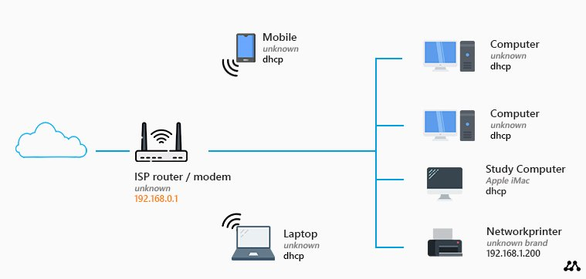

This is the most basic home network diagram that you can have. We have a router with a built-in modem and an access point that we got from our ISP (Internet Service Provider). These kinds of routers typically allow you to connect up to four devices using a network (UTP) cable.

If you look at this network diagram, you might think, this is all I need. I can connect my computer(s) and printer with a network cable and wirelessly connect my mobile phones and/or laptops.

But there is a big downside to this layout. You will have to place the router close to the point where the internet connection comes into your house. Most of the time this is hidden in a utility room or garage. The wireless network range is limited, so you probably won’t have a good wireless network connection with this setup.

You can only connect four wired devices. Keep in mind that a wired connection is the best connection that you can have. So ideally you want to connect your Smart TV, Game console, Printer, etc with a wired connection. Then 4 network connections aren’t a lot.

Your available options for connecting devices for this task is below along with their definitions.

Wired Access Point: An Access Point (AP) is a device that can send and receive data. It receives an internet signal through an Ethernet cable connection to the router and converts it into a separate Wi-Fi network.

Cloud: A vast network of remote servers

Modem: is a device connecting your home to your internet service provider (ISP) through a physical connection. The modem translates the data from your ISP into a format that your home network devices can use.

Wireless Router: A router is a device that provides Wi-Fi and is typically connected to a modem. It sends information from the internet to personal devices like computers, phones, and tablets. These internet-connected devices in your home make up your Local Area Network (LAN). It allows for the connection of 5 wireless devices. Multiple Wireless Routers can be installed in a home

Wireless Bridge: The wireless bridge converts any wired network enabled device with available Ethernet port to latest wireless technology.

Your task for this assignment is to place electronic devices around your house and create a network diagram which will allow these devices to connect. The list of Electronic Devices is below for you. You must use all in the required devices list in your floor plan and network diagram, as well as a minimum of 3 from the optional devices list.

*Tip: Read the information and definitions on the previous page to help you!*

|  |  |
| --- | --- |
| Required Devices | Optional Devices (Minimum of 3) |
| * Computer (Desktop) * 1 x Laptop * 4 x Mobile Phones * 1 x Tablet (eg. Ipad) * 1 x Smart TV | * Gaming Consoles * Smart TV’s * Laptops * Printer * Smart Home Device (eg. Google Home or Amazon Alexa) * TV Stream (eg. Amazon Firestick or Google Chrome Cast * Mobile Phones * Tablets (Ipad) |

Now you have chosen al the devices you are going to use, the next step of your task is to label where abouts in the house you are going to put these devices.

Label the diagram on the following page as to where abouts in your house you want to place all these devices. The next page is a draft copy. You will be given a final A3 Good Copy by your teacher.

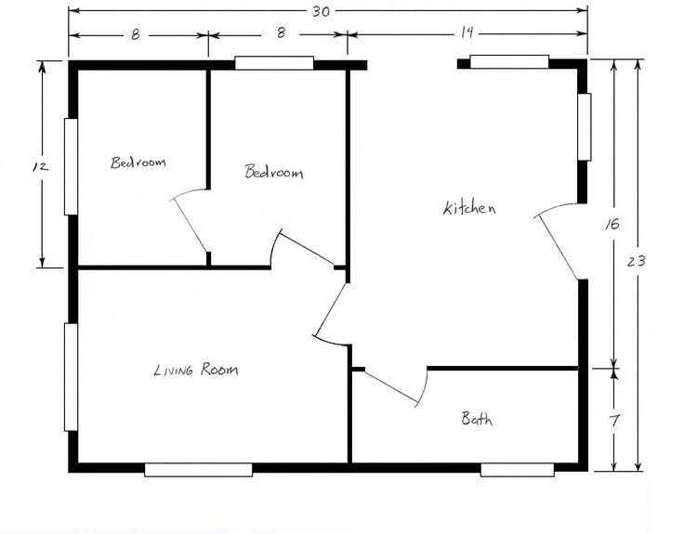

Part 2 – Network Diagram

Now that you have decided where abouts in your house you are going to place your electronic devices, the next step is to create a Network Diagram.

Below is an example network diagram. You are to create one of these connecting all the devices in your house. You have access to all equipment listed on the front page to help you connect all your devices.

Draw a draft network Diagram in the box below. Then create a good copy using the computer. A PowerPoint has been created for you with the correct CISCO symbols for you to use (on connect) in your good copy.

**Task 2 – Part B – Paragraph**

You are required to write a PowerPoint explaining the choices that you made for your home network.

Use the draft paragraph below to help you create your paragraph. This can be in DOT Points. You will then write out your draft paragraph in full sentences on the following page.

Your good copy will need to be typed up.

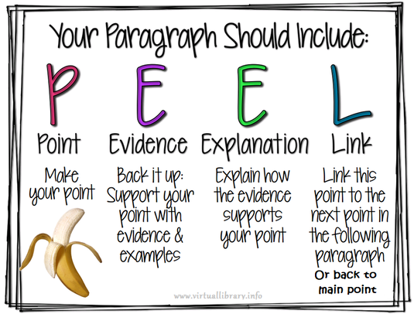

**Draft Paragraph**

*Use dot points*

|  |  |
| --- | --- |
| **POINT**  What are you going to be communicating.  Eg. Your home devices network |  |
| **EVIDENCE**  What equipment have you chosen to use. |  |
| **EXPLANATION**  Why have you chosen to use that equipment |  |
| **LINK**  Link your paragraph back to the main point. |  |

Turn the dot points above into a paragraph using full sentences below.

_____________________________________________________________________________________________________________________________________________________________________________________________________________________________________________________________________________________________________________________________________________________________________________________________________________________________________________________________________________________________________________________________________________________________________________________________________________________________________________________________________________________________________________________________________________________________________________________________________________________________________________________________________________________________________________________________________________________________________________________________________________________________________________________________________________________________________________________________________________________________________________________________________________________________________________________________________________________________________________________________________________________________________________________________________________________________________________________________________________________________________________________________________________________________________________________________________________________________________________________________________________________________________________________________________________________________________________________________________________________________________________________________________________________________________________________________________________________________________________________________________________________________________________________________________________________________________________________________________________________________________________________________________________________________________________________________________________________________________________________________________________________________________________________________________________________